ACCT 4110 – TAXATION II
Short Answers
- List the three sources of tax law. Provide a brief statement about each.
One of the things we need to know is all about a substantial tax authority, which are sources that tell us whether an item is taxable, deductible, included or excluded from taxation. The three sources of tax authority are:
- Legislative law
- Administrative law
- Judicial law
Legislative Law – when we think about legislative law, what comes in mind is the Congress. It is the original source. In contrast to administrative law and judicial law, which are interpretation of the law itself. It is written by the U.S Congress. For example, Tax Cuts and Jobs Act, and also Tax Treaties that govern income earned in foreign countries. Two more examples of a legislative law are the Internal Revenue Code and Congressional Committee reports, which are primary sources of federal tax law.
Administrative Law – when we think about the administrative law, think about the department of Treasury. These are tax rules, regulations, and procedures implemented and enforced by the Treasury Department. The IRS is a bureau of the Treasury Department. Examples of administrative laws set under this department include:
- Treasury regulations
- Revenue ruling
- Revenue procedures
- Internal revenue bulletin
- Technical advice memoranda
- Private letter ruling
- IRS Publications
Judicial Law – When you think of judicial law think of the judicial system-judges. These laws originate from the federal court system or what is called common law and they are primarily composed of court opinions. In other words, court cases are considered a primary authoritative source when conducting tax research.
- If a taxpayer has a disagreement with the IRS and has exhausted all administrative efforts, which courts of original jurisdiction will hear his case? (list all)
If a taxpayer has exhausted all administrative efforts without any satisfactory settlement, then the dispute can be taken to a higher level i.e., a federal court. Before that, the dispute would be taken through a trial and, of course, in condition that it is appealed either by the taxpayer or the IRS. An appellate court is charged with reviewing a reviewing the record of trial from the trial court. Generally, the courts of original jurisdiction that are likely to hear the case may include: the U.S. Tax Court, Federal District Court, the U.S. Court of Federal Claims, and/or the Small Cases Division of the U.S. Tax court.
- In the question above, explain the differences between the courts with respect to: payment of deficiency before trial, jury trial and types of disputes.
- The U.S Tax Court of federal claims comprises of 16 judges. In this court, there is payment of deficiency before trial. The court does not handle any jury trials and the types of disputes handled here are any claims against the united states.
- The number of judges in the Federal District Court varies. There is payment of deficiency before trial. The court has a jury trial and the types of disputes handled in these courts are criminal and civil issues.
- The U.S. Tax Court/Small Cases- this court comprises of 19 judges. There is no payment of deficiency before trial and the types of disputes handled here are tax cases.
Name two on-line tax research sites/software (other than CCH) and provide the web info to access each. Include a copy of the home page of each.
- Name two on-line tax research sites/software (other than CCH) and provide the web info to access each. Include a copy of the home page of each.
Two of the most widely used online tax research sites are:
- http://www.taxalmanac.org – provide a tax library and a platform where tax professionals exchange industry knowledge, discuss tax issues and gain fresh insights, share resources, and so forth.
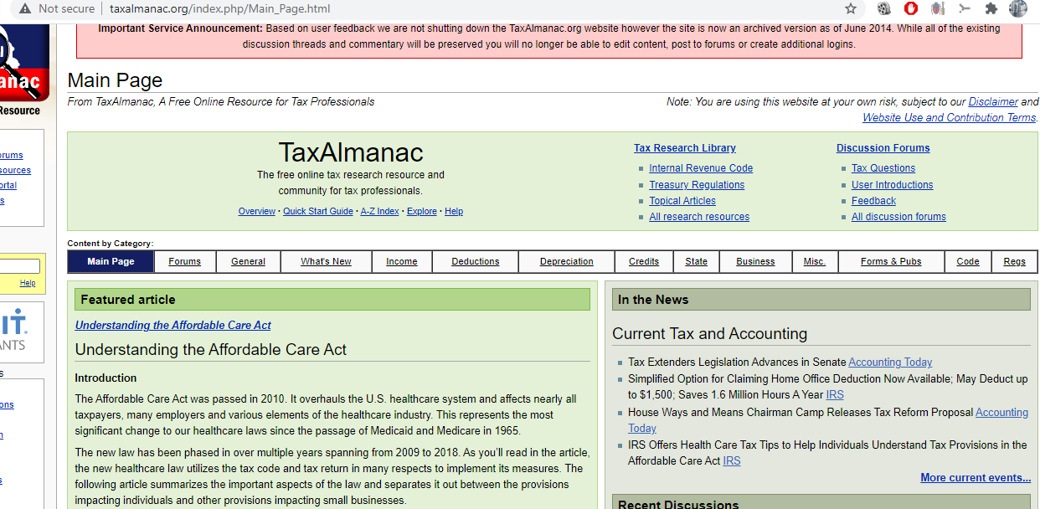
- https://www.irs.gov – this is a government website providing information about tax responsibilities. It is the taxpayers first option whenever they have questions about taxes. Also it allows people to file federal tax returns for free, apply for payment plans, check tax withholding, and so forth.

- How do you access CCH via the WPU web page? Provide a copy of the home page.
- First, visit http://www.wpunj.edu/
- Under academics, go to “Library”
- Select “Database”, then from the alphabetical database list, select “C”
- Find on the listed items “CCH Internet Tax Research Network” and click its link.


Part 2
Tax Research
Statement to the Client
Based on the research conducted on both taxable and nontaxable income, the inventory was subject to federal taxation as it creates a taxable income. Think about every dollar it earned for you every year; a taxable income would be on the profit or capital gains you make, but the good thing is that you can request a deduction to reduce the accrued taxable income. There are certain work-related expenses you can claim you did to be able to do your job and earn an income. That may include things like work-related travel costs, special clothing, tools of trade, and self-education.
If you received the inventory as a gift, then the U.S federal code §102(c) can help reduce the taxable income. It allows the taxpayer to exempt the value on the income tax. However, it was received from the employer, then it must be included in the income tax. This regulation is subject to two exceptions. Under The U.S federal code §26 US code 132, certain fringe benefits should not be included in the gross income (Cornell Law School, 2021). Such may include things like transport fringe, retirement planning service, working condition fringe, employee discount, and so forth.
Whether or not an inventory is offered as a gift, the court might be correct in holding that it is necessary to determine the intention the inventory owner had when he decided to transfer or give it out. The U.S Internal Revenue Code section 102(b) (1) states that any income derived from a property received as a gift should not be excepted from the recipient’s income tax. That means that the giver must not try to manipulate the provision (Hasen, 2018). The income tax must be included whether it is a gift or not.

Question Presented
TAX FILE MEMORANDUM
DATE: November 6, 2021
FROM: xxxxx
Subject: IRS Audit of Kane Corporation’s
Today, I talked to Shelly regarding proper tax treatment of Kane Corporation’s transfer of its entire inventory (basis of 1.2 million) in a transaction described as a “sale” by both the parties. The sale price for the inventory was 2 million, which was based on fair market value and which Shelly was to pay at a future date. Unfortunately, the debt was not evidenced with a promissory note and until today Shelly has not made any payment.
The other fact is that:
After the inventory transfer, Kane ceased to operate and, therefore, did not liquidate as required by state law. Upon an audit of Kane’s tax return, IRS discovered that the inventory transfer constituted a liquidation of the corporation that resulted to $800,000 [$2 million (fair market value) - $1.2 million (inventory basis)]. Since Kane is devoid of assets, the IRS had no option than to assess the tax against Shelly, based on transferee liability. IRS also asserts that Shelly has a tax deficiency based on the gain she recognized on the purported liquidation.
Research Conclusion
The best approach to help Shelly and determines whether or not IRS was correct in its determination, is first off to determine whether the inventory transfer really constituted a complete liquidation of Kane Corporation as required by Section §346 (complete liquidation) of the tax law. Kane did not have a formal plan stating its plan to liquidate including distributing the properties. I.R.C. §346(a) requires that a distribution be treated as incomplete liquidation of a corporation if it did not have an intent to liquidate or even does not explain how the distribution would play out, its effect on corporate or shareholders and determine tax consequences. Even though the corporation did not have a formal plan, agreeing to transfer the inventories is evident enough it had an intent to liquidate and, therefore, the transaction qualifies as a complete liquidation. Alternatively, if Shelly can prove that the corporation is still under the process of liquidation, then the transaction can be characterized or treated as a non-liquidating distribution and, thus, potentially a dividend under section §301.
- Consequences to Shelly
IRS is correct by asserting that the inventory transfer constituted a complete liquidation. Thus, under I.R.C §1001(a), the corporation would have realized $800,000 [$2 million (fair market value)] gain on the distributed inventory. Treating the transfer on the basis of transferee liability, Shelly is tax liable because she assumed the liability the moment the inventories were transferred to her. She would have a recognized gain of 1.6 million [$2 million (inventory value- $400,000 (stock basis)], reduced by the corporation’s tax liability on liquidation.
- Consequences to the Corporation
The question to answer here is “how much gain or loss did the corporation realized and recognized?” Section I.R.C §336(a) states that gain or loss should be recognized as if such property were sold to the distributee at its fair market value”, unless the property distributed to the shareholder is subject to a liability. Based on this general rule, the corporation does not have any tax consequence because its liability was transferred to Shelly.

Part 3
Improper Accounting for Sales
DATE: November 6, 2021
FROM: xxxxx
Subject: Improper Accounting of Sales
Ethics is important in accounting. In its absence, financial statements cannot be correct. The fact that the production managers authorize staff purchases of goods manufactured by the company is a clear violation of the accounting principle that requires all productions and sales made be reflected in the financial statements, and their accounting done correctly." Failure to follow this principle should be treated as fraud committed by the production managers. Sarbanes Oxley Act requires top management to certify the responsibilities of the financial statements, including supervising the audit of reports and ensuring their accuracy (Biden Jr, 2002). Since the top management does not carry out this obligation, it exposes the organization to the risk of incurring hefty fines and imprisonment.
Accordingly, all members of the accounting profession must adhere to the fundamental principles under professional ethics. According to Colquitt & Salam (2009), an auditor must demonstrate some levels of integrity. Omitting income from staff sales in the financial statements and returns to the tax authority could be misleading. Such a practice exhibits dishonesty, and as an auditor, the practice should be reported to the relevant authorities should the company repeat the same mistake repeatedly. However, auditors should provide relevant advice to their clients and ensure that all accounting standards are followed.
Regardless of the close relationship with the directors and staff of the company, I would consider being more objective by doing the right thing because that's what ethics is all about. Doing the right thing means observing all technical and professional standards, and especially the principles of accounting. It would be ethically wrong and unprofessional to ignore these principles by acting in favor of any party. According to Fearnley et al. (2005), objectivity means being detached or independent from the company, given that our first obligation should be professionalism. The greatest asset of an auditing firm is its reputation, and, therefore, maintaining a good reputation is key. I would also ensure that I'm competent in terms of how I perform tasks and, most importantly, be careful and behave professionally. That means complying with the rules and regulations and not engaging in any activity that would harm my profession's reputation or that of the audit firm. Competence delivers results in terms of providing accurate and appropriate advice to the client.

References
Cornell Law School (2021). The U.S federal code §26 US code 132 – Certain Fringe Benefits. Retrieved from https://www.law.cornell.edu/uscode/text/26/132
Hasen, D. (2018). How Should Gifts Be Treated under the Federal Income Tax. Mich. St. L. Rev., 81.
Biden Jr, J. R. (2002). Certifying Statements under Section 906 of Sarbanes-Oxley Act: Holding Corporate Executives Accountable for the Accuracy of Corporate Financial Statements. Fed. Sent. R., 15, 257.
Colquitt, J. A., & Salam, S. C. (2009). Foster trust through ability, benevolence, and integrity. Handbook of principles of organizational behavior: Indispensable knowledge for evidence-based management, 389-404.
Fearnley, S., Beattie, V. A., & Brandt, R. (2005). Auditor independence and audit risk: A reconceptualization. Journal of International Accounting Research, 4(1), 39-71.

